* Input a text in the console.
* Check if the text contains only sorted digits (from lowest to highest values)
* If so, write SORTED, otherwise write NOT SORTED

1. What will be the **result** for these outputs?

|  |  |
| --- | --- |
| **Input** | **Output** |
| 489 | SORTED |
| 4762 | NOT SORTED |
| 12 | SORTED |
| 1268 | SORTED |
| 1896 | NOT SORTED |
| 1536 | NOT SORTED |
| 2789 | SORTED |

1. How many parts can you divide the problem into? Individual work.

1.created variable for input

2.Set result to “Sorted”

3.Use for loop for repeat indext

4. check condition if

5.print

1. Create the flowchart structure of your algorithm. Team (3 students) work.

start

Get text

Result=”SORTED”

Len(text)-1

Text[i+1]<text[i]

Print(result)

Result=”Not Sorted”

End

1. Implement your code. Team (3 students) work.

Text=input()

Result=”sorted”

For i in range(len(text)-1:

If text[i+1]<text[i]:

Result=”not sorted”

Print(result)

1. Execute it in a table of execution. Team (3 students) work.

|  |  |  |  |  |  |  |
| --- | --- | --- | --- | --- | --- | --- |
| Step | text | result | i | Len(text)-1 | Text[i+1]<text[i] | output |
| 1 | 123 |  |  |  |  |  |
| 2 |  | sorted |  |  |  |  |
| 3 |  |  | 0 |  |  |  |
| 4 |  |  |  | 3 |  |  |
| 5 |  |  |  |  | false |  |
| 6 |  | Not sorted |  |  |  |  |
| 7 |  |  |  |  |  | Not sorted |

* Input a text in the console.
* Control that the text is owning only "abc" pattern.
  + Print “OK” if so
  + Otherwise, print “WRONG”

1. What will be the **result** for these outputs?

|  |  |
| --- | --- |
| **Input** | **Output** |
| abcd | WRONG |
| abcabc | OK |
| abc | OK |
| aabc | wrong |
| abbc | wrong |
| abcabcab | wrong |
| abcdefg | wrong |

1. Create your flowchart structure with black boxes.

* Each student has to create his own.
* Share the result in group of 3.

start

Get text

Done

Len(text)-2

Text[i]=”a”

And text[i]=”b”and text[i]=”C”

Print(result)

no

yes

Result=”ok”

End

1. Implement it in Python. In group of 3.

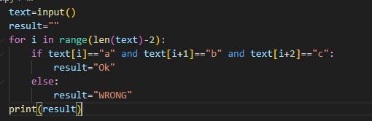

1. Fill up the execution table. In group of 3.

|  |  |  |  |  |  |  |
| --- | --- | --- | --- | --- | --- | --- |
| Step | text | i | Len(text)-2 | Text[i]==”a”and text[i]==”b”and text[i]==”c” | result | output |
| 1 | abc |  |  |  |  |  |
| 2 |  | 0 |  |  |  |  |
| 3 |  |  | 1 |  |  |  |
| 4 |  |  |  | ok |  |  |
| 5 |  |  |  |  | ok |  |
| 6 |  |  |  |  |  | ok |
| 7 | abcd |  |  |  |  |  |
| 8 |  | 1 |  |  |  |  |
| 9 |  |  |  | wrong |  |  |
|  |  |  |  |  | wrong |  |
|  |  |  |  |  |  |  |
|  |  |  |  |  |  |  |
|  |  |  |  |  |  |  |

1. Present your flowchart structure to the class. In group of 3.

* Input a text in the console.
* Check that the text:
  + Has only *y*, between square brackets (need open AND close brackets).
  + Otherwise has *x*
* If the text is correct
  + Print “OK”
  + Otherwise, print “WRONG”

1. What will be the **result** for these outputs? Individual work

|  |  |
| --- | --- |
| **Input** | **Output** |
| xxx[yyy]xxx | Ok |
| [yyy]xxx | OK |
| xxx[yyy | WRONG |
| xxxy | WRONG |
| [yy] | OK |
| xxx[yxyy]xxx | WRONG |
| xxxxx | WRONG |

1. Which main instruction can solve the problem? What will it be used for? Group of 3 students.

The main instruction we can sovle the problem we should use for loop in oder to this program

1. Create a code to solve this problem. Group of 3 students.

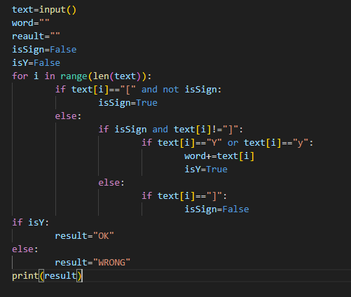

1. Present your solution to the class. Group of 3 students.

Step1:created variable for input

Step2:set variable to False

Step3:set result=”” for store output

Step4:Use for loop for repeat len text

Step5:Use if else for check condition